Polymicrobial Infection in COPD exacerbation

Drupad Das, *Prasan Kumar Panda
Department of Medicine (ID Division), All India Institute of Medical Sciences, Rishikesh, Uttarakhand, India
*Email:motherprasanna@rediffmail.com

Case Vignette
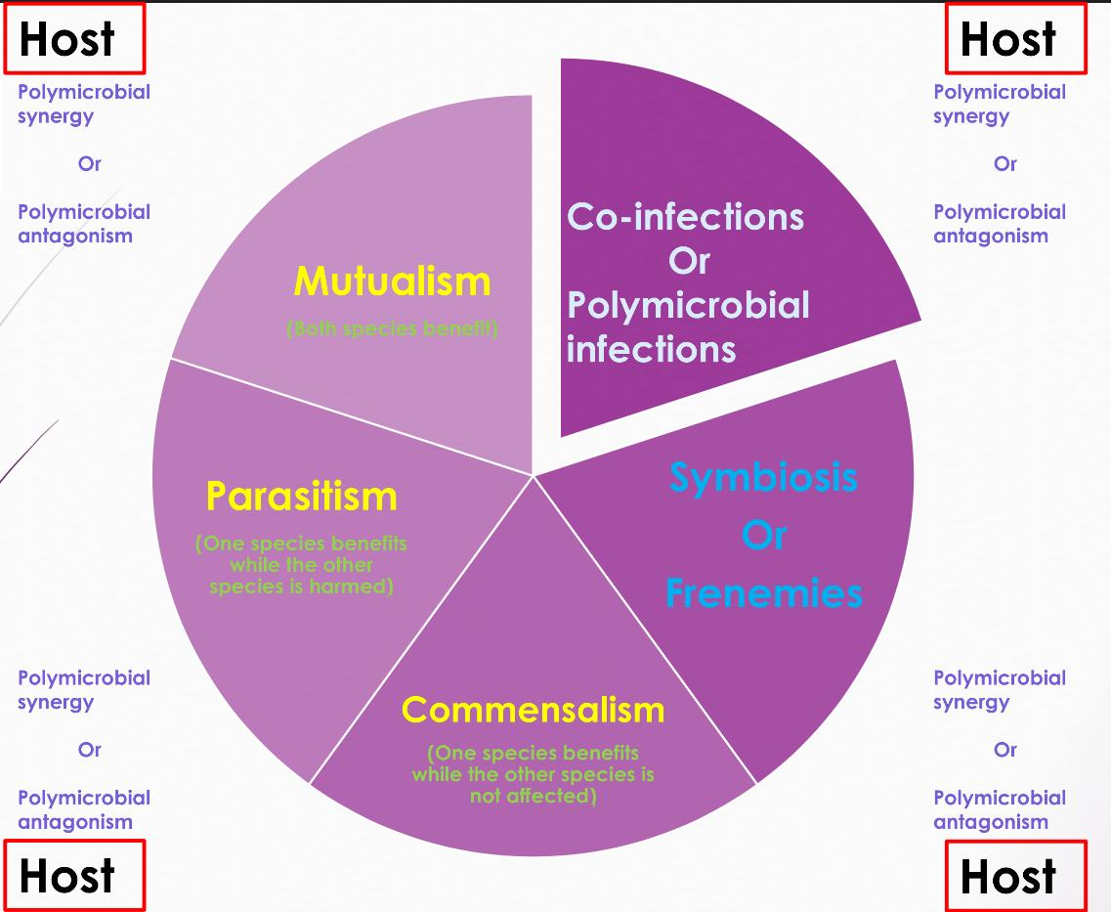
A middle-aged, thinly built woman who smokes beedi and has a history of biomass exposure, has been suffering from COPD for the last 4 years. She has been taking inhaled betamethasone and tiotropium. Additionally, she had uncontrolled diabetes for a few months. She presented with fever, productive cough, shortness of breath, and chest pain for 5 days. Chest X-ray and CT confirmed pneumonia, cavities, and abscesses in both lungs. Repeated sputum and bronchoalveolar lavage confirmed Pseudomonas aeruginosa and Aspergillus fumigatus. Along with supportive therapy, she was treated with tablet levofloxacin and injection amikacin for 6 weeks based on culture sensitivity reports, and capsule itraconazole for 6 months. She recovered completely to her baseline COPD and diabetes status.

Q. What is this polymicrobial diagnosis (figure) in this patient?
A. Polymicrobial - Synergy
B. ⁠Polymicrobial- Antagonism
C. ⁠Polymicrobial- Mutualism
D. ⁠Polymicrobial- Commensalism

Answer:- B. Polymicrobial antagonism
Comments
While Pseudomonas inhibits fungal growth and biofilm production, the interaction between Pseudomonas and Aspergillus is complex, with both organisms inhibiting each other’s growth. A. fumigatus not only endures the antifungal effects of P. aeruginosa but also protects itself. Phenazines, the quorum sensing system, iron competition, bacteriophages, and small colony variants of A. fumigatus inhibit fungal biofilm formation. Conversely, A. fumigatus’s siderophores, phenazine metabolic transformation, gliotoxin production, and reduced antibiotic sensitivity inhibit bacterial biofilm formation. Pseudomonas can inhibit the growth of Aspergillus conidia but cannot inhibit preformed hyphae, likely due to the gliotoxin production by the hyphae.
Reference
Das D, Panda PK. BMJ Case Rep 2024;0:e259285. doi:10.1136/bcr-2023-259285

